# Rack Authorization

Brief Summary

This document contains a few screenshot for how Rack Authorization works in VDC/MAM

I have created two Device Group

DEV Rack Group

* it contains one rack: audit-rack

DEV Server Group

* it contains one server: audit-server

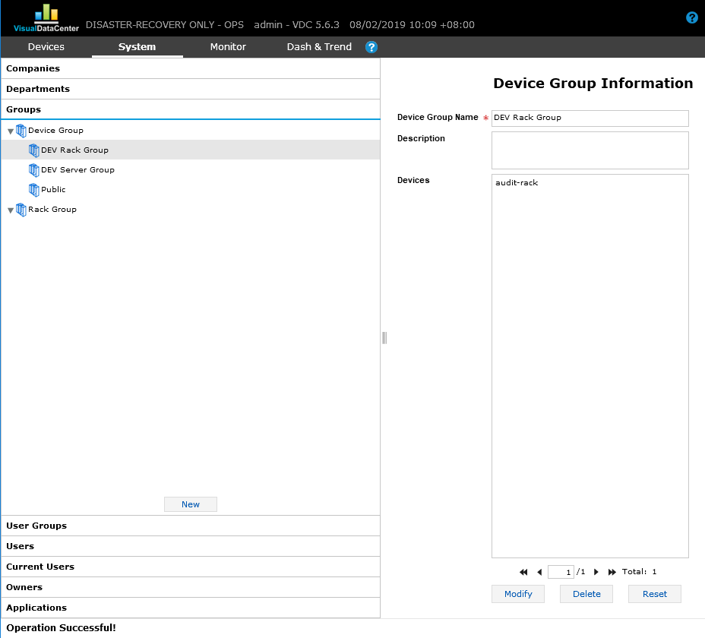

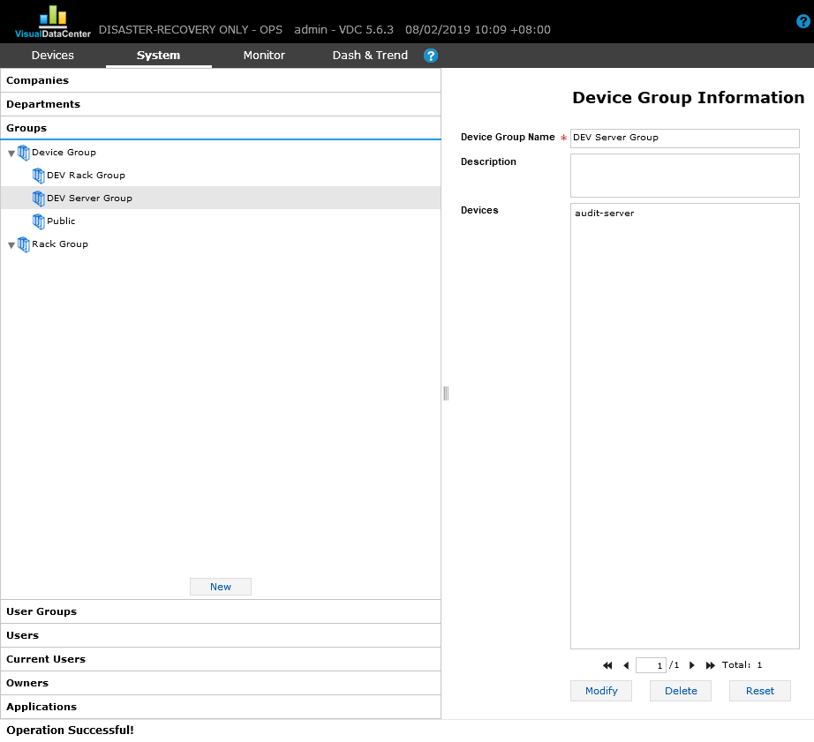

There are 3 user groups

Group A

Saved with device group: DEV Rack Group.

It has right access to the device: audit-rack.

Group B

Saved with no device group.

It has no right access to any device.

Group C

Saved with device group: DEV Server Group

It has right access to the device: audit-server

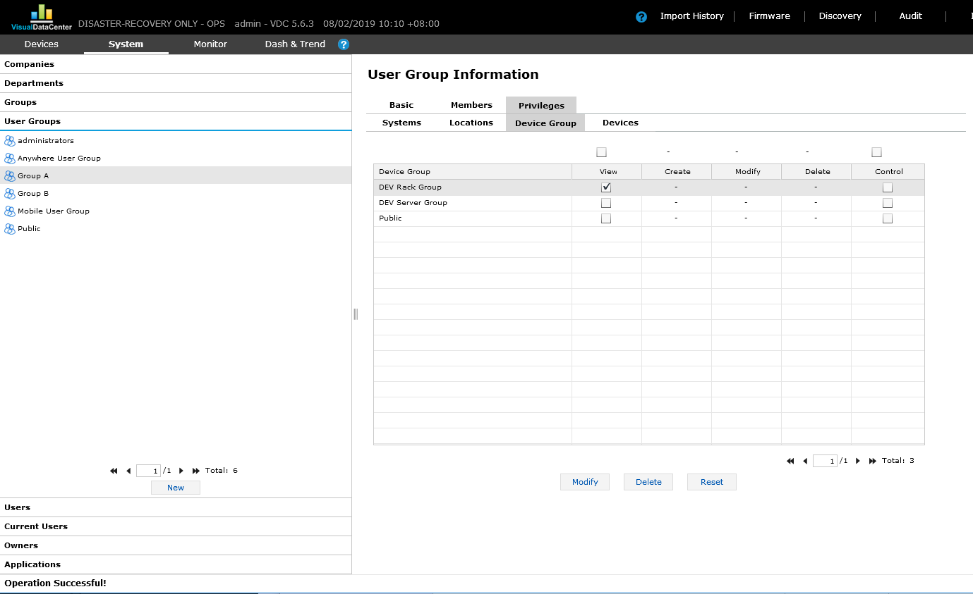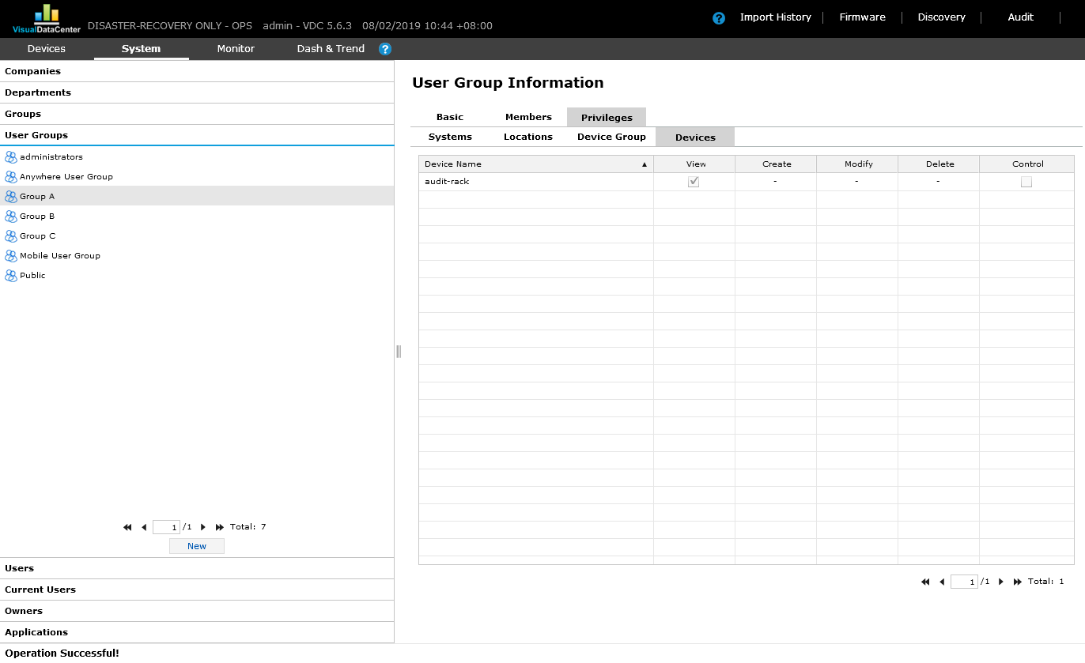

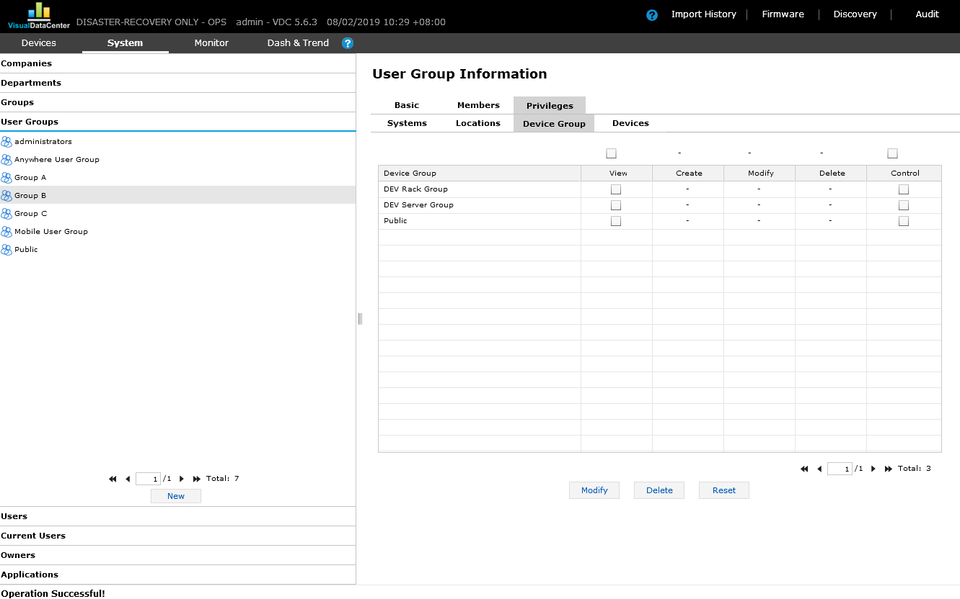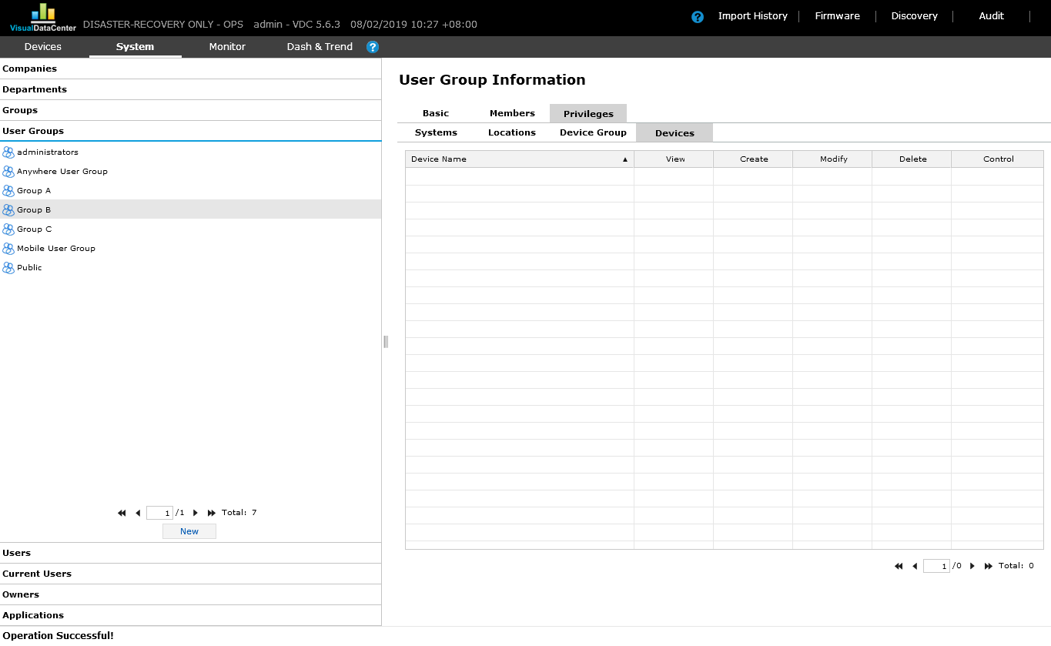

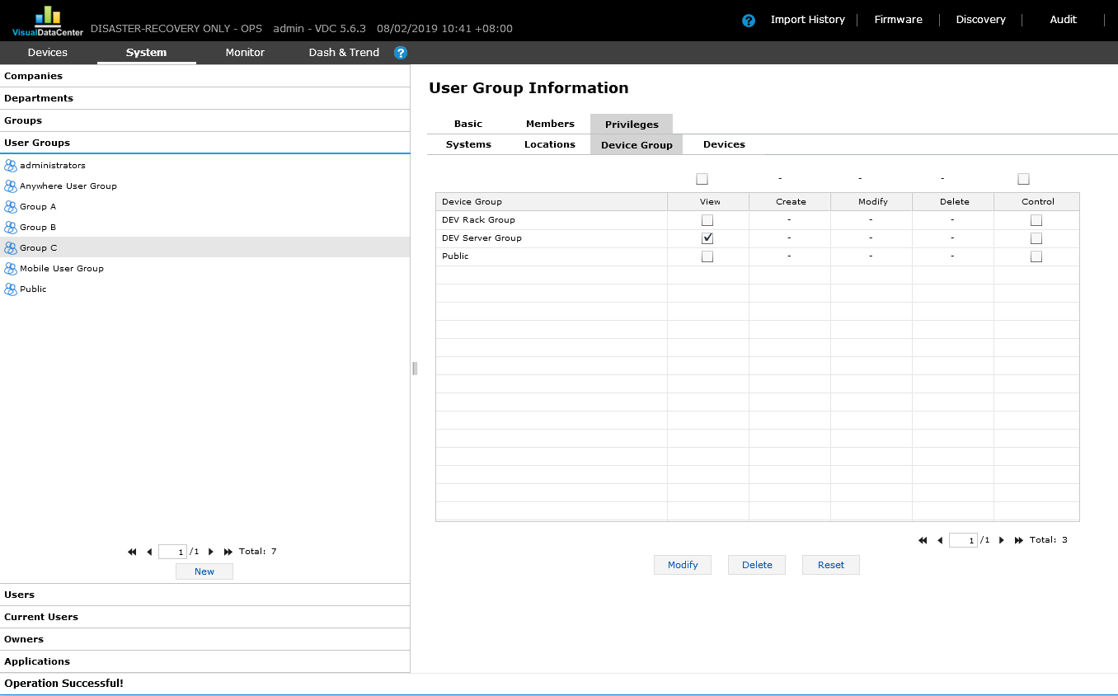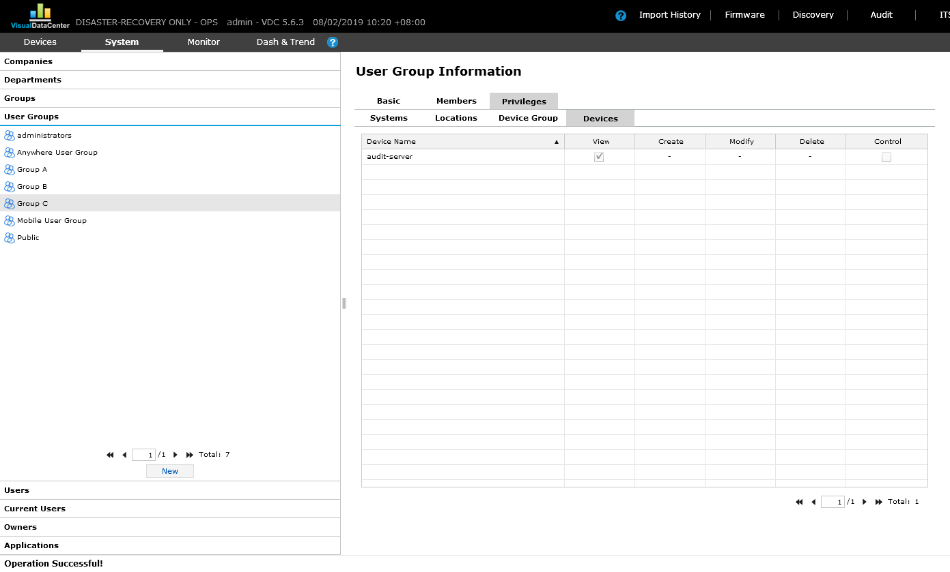

There are 3 users

User A - belongs to Group A

User B - belongs to Group B

User C - belongs to Group C

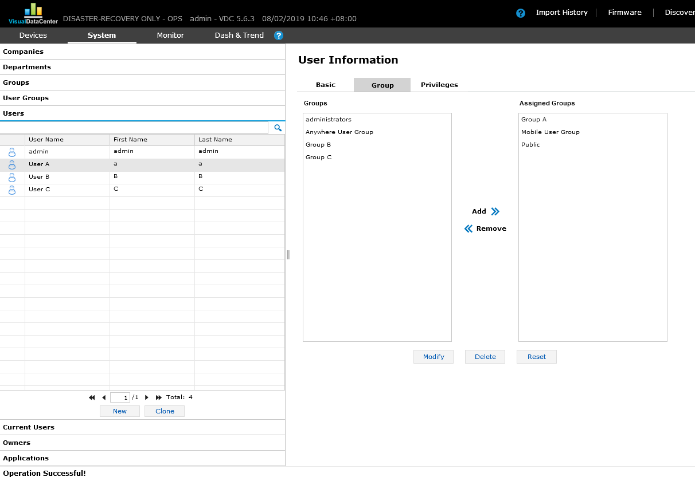

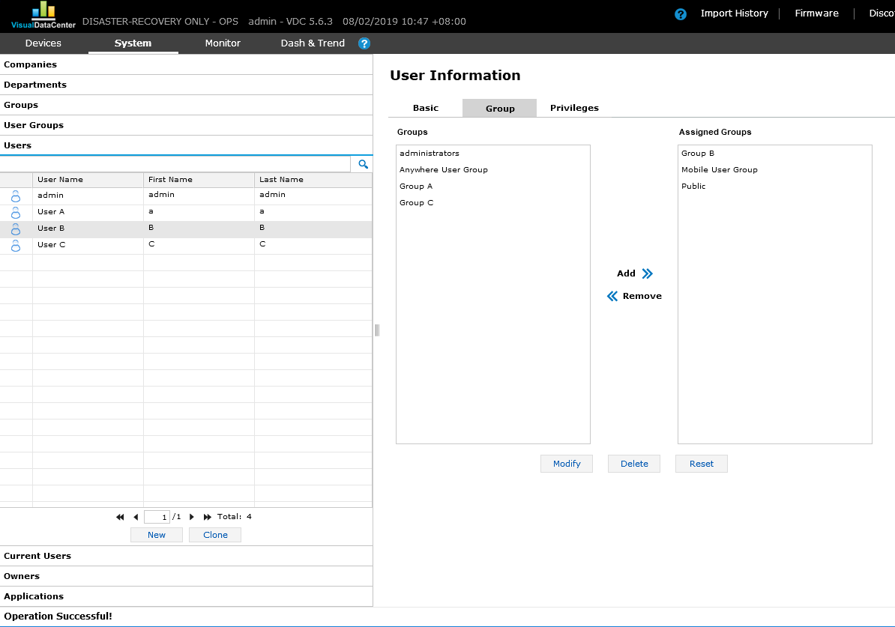

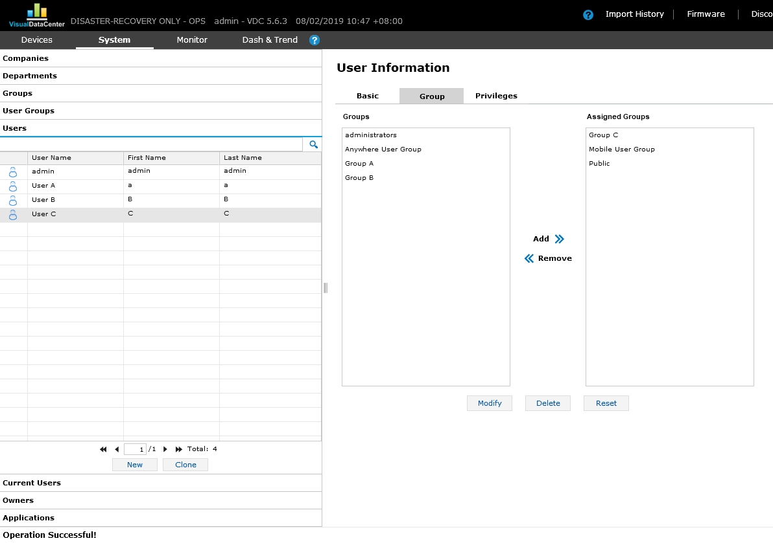

There is a task for moving audit-server to audit-rack.

One audit is generated:

Generated_Audit_[004]_[1584051]

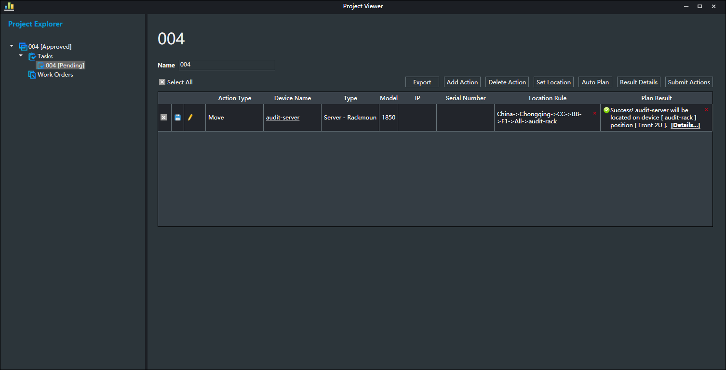

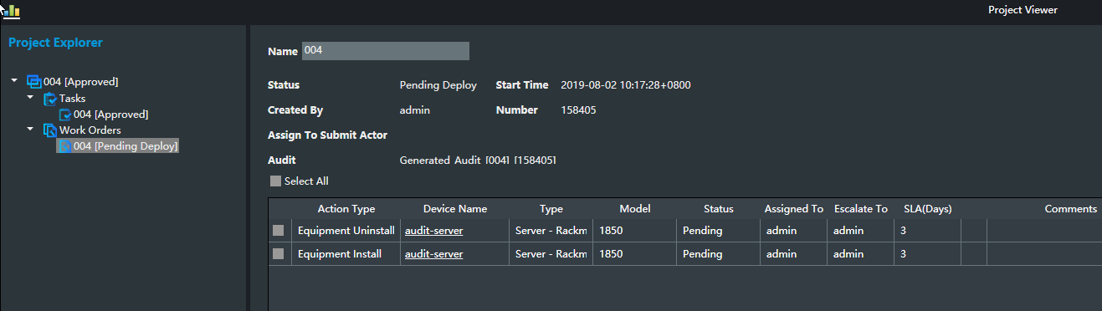

Login with User A

Generated_Audit_[004]_[1584051] is listed

audit-rack is listed

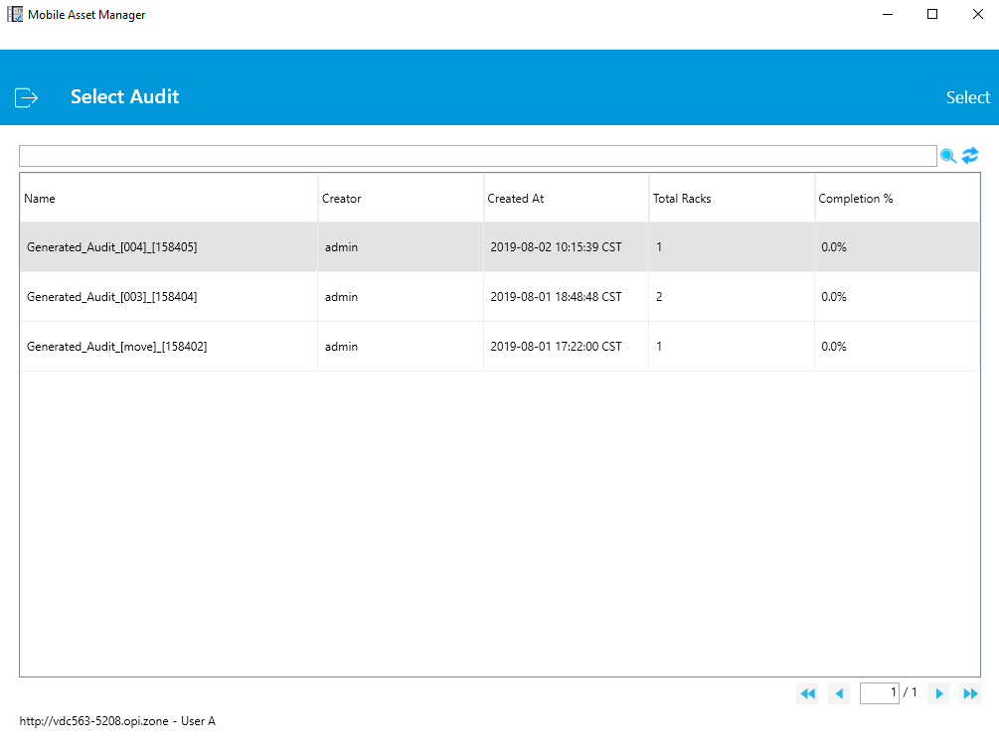

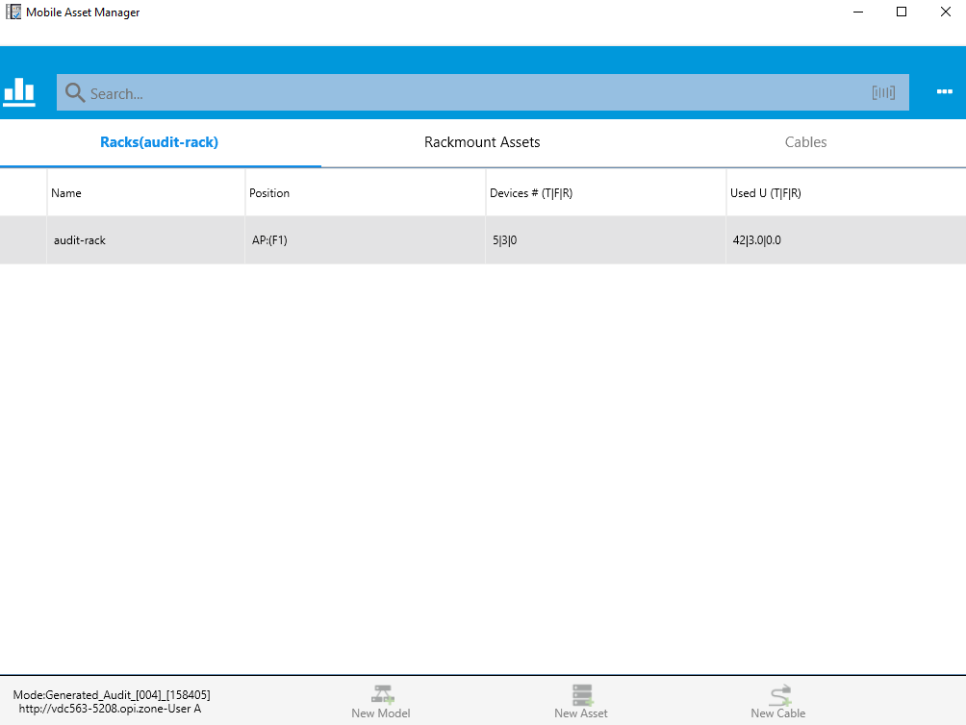

Login with User B

No audit is listed.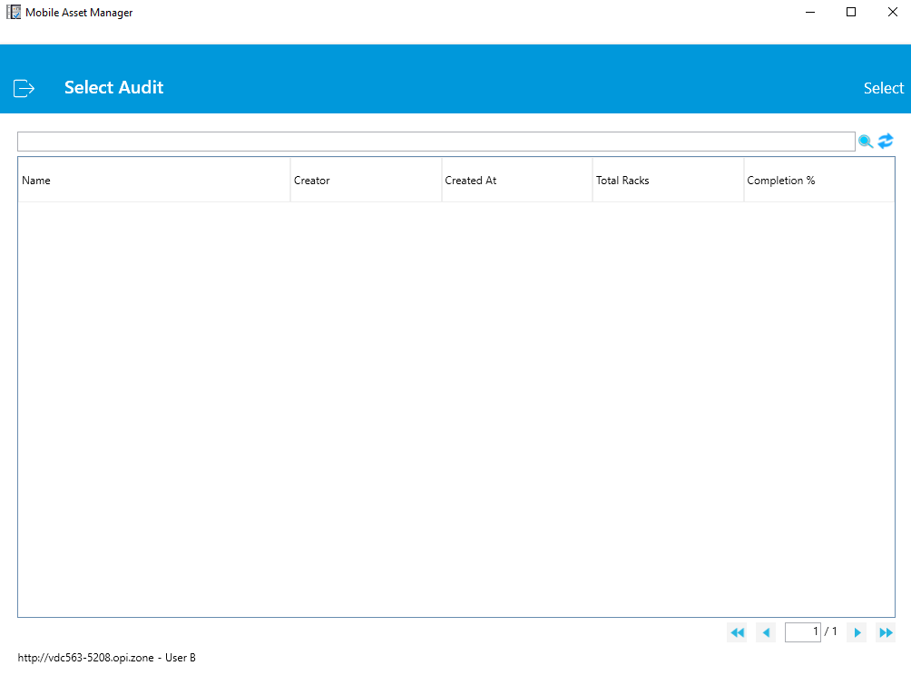

Login with User C

Generated_Audit_[004]_[1584051] is listed

audit-rack is listed

